Problem 1 : Flatten the Nested Array Elements

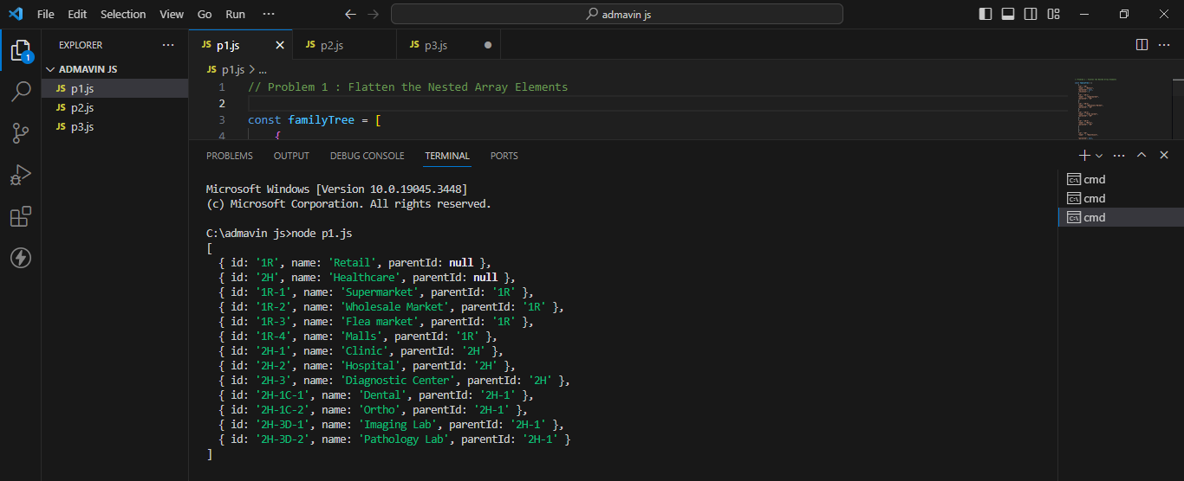

Problem 2 : Finding Steaks

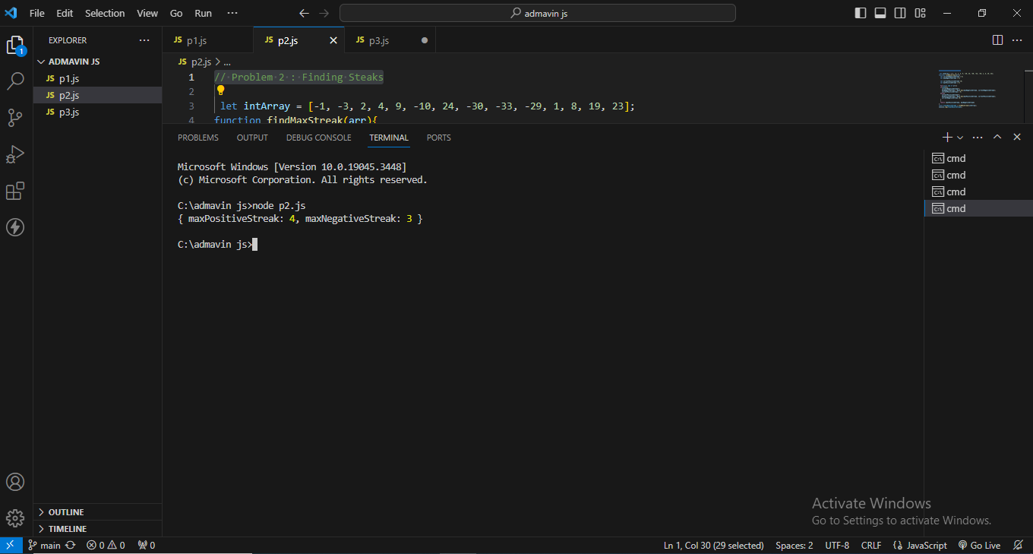

Problem 3 : Object Sorting

